Churn Data Analysis on Telcom Data

**Task 1**: Full Stream

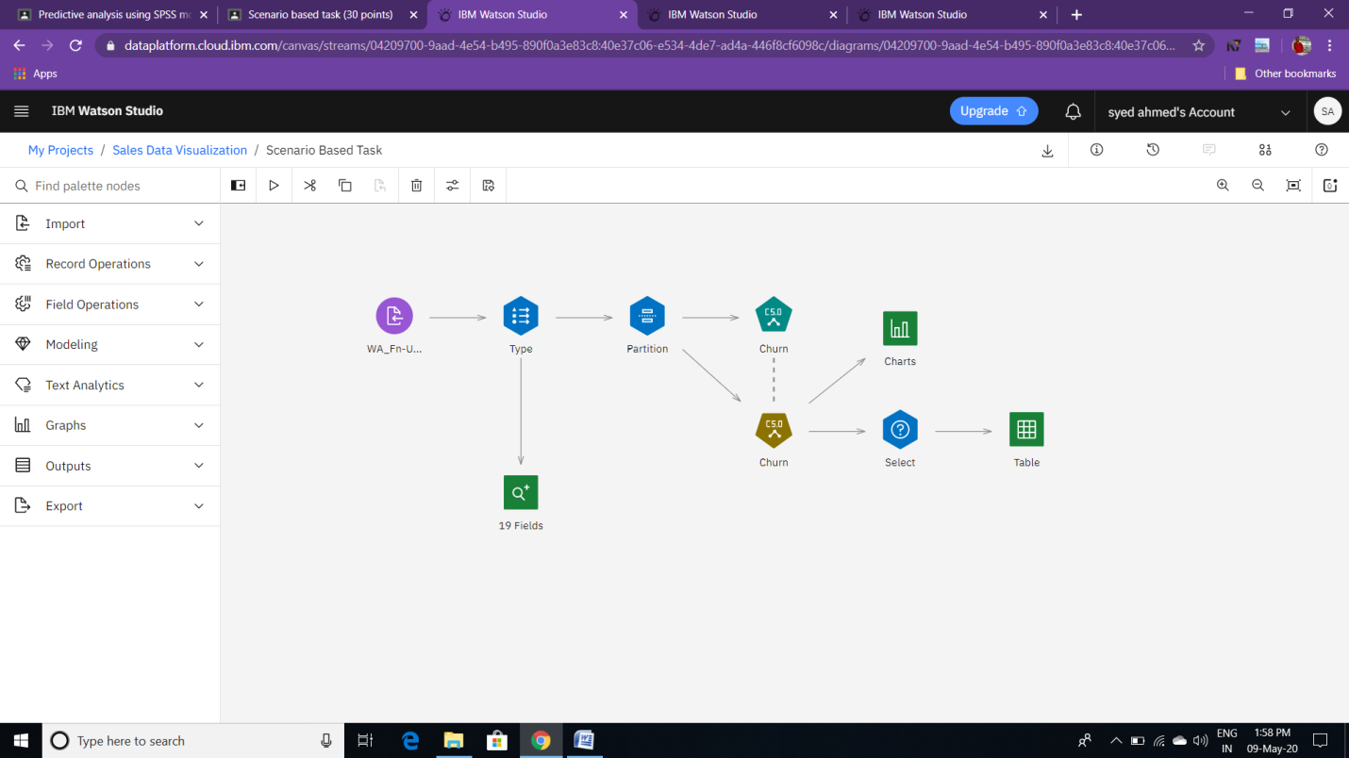

**Task 2**: Connected Data-Audit Node to the type Node to check whether there are any kind of Null/Blank Values. We found that there are no Null/Blank Value.

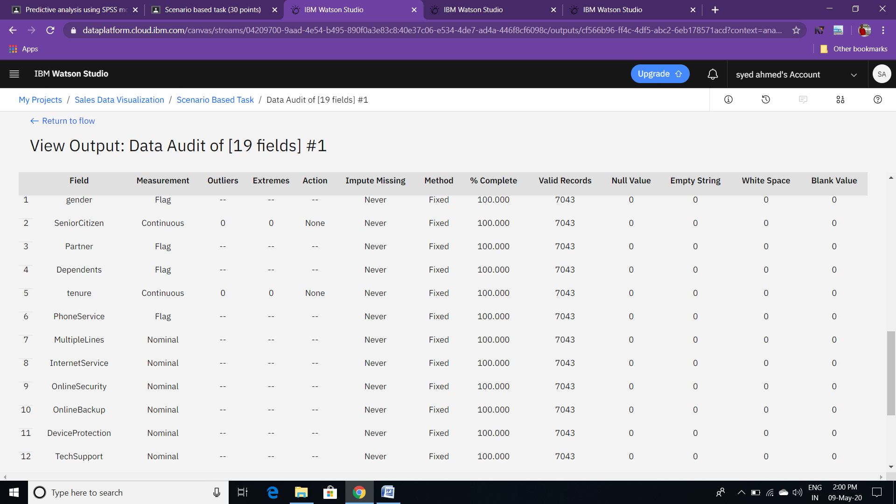

**Task 3:** Here I have attached partition node to the type node to increase the Model-Accuracy.

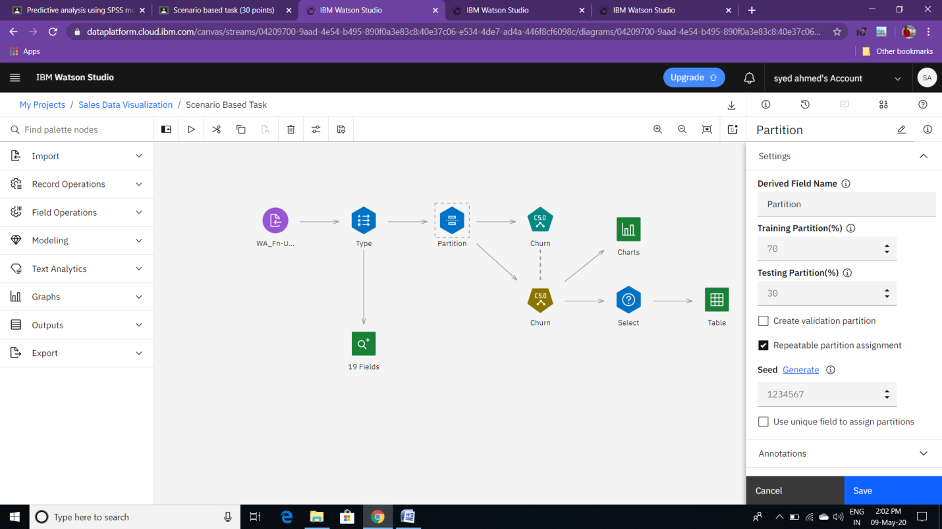

**Task 4**: Attached C5.0 Model. Also , It displays the input v/s output field.

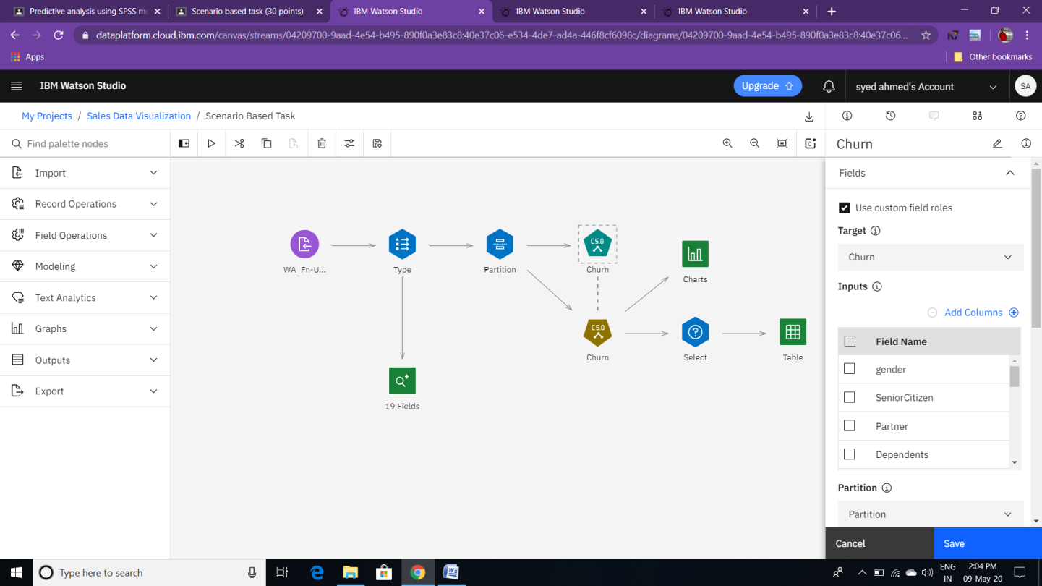

**Task 5**: Top Decision Rules.

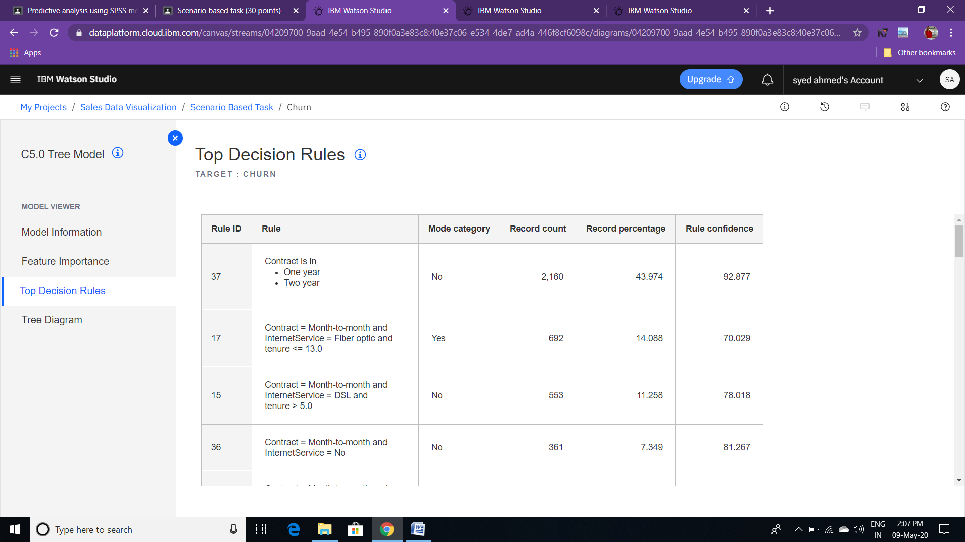

**Task 6**: Tree Diagram.

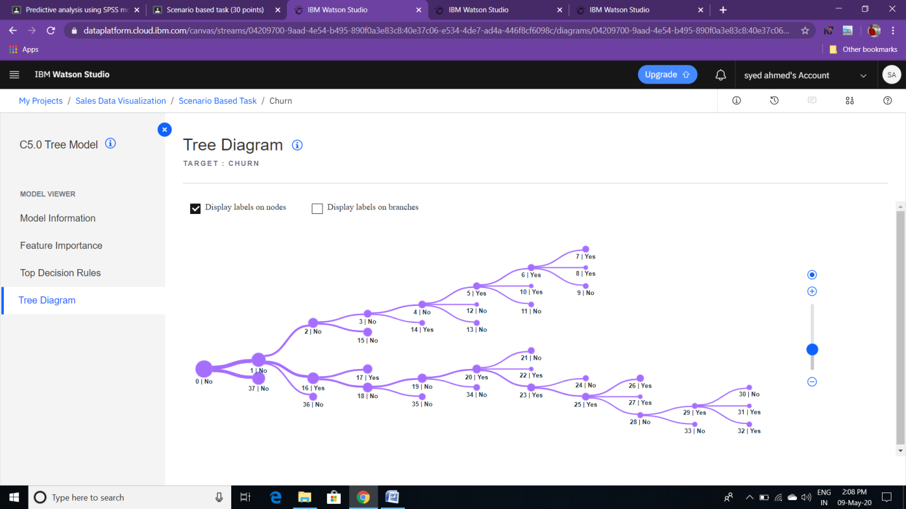

**Task 7**: Usage of Select Node to satisfy the criteria of the customers who are going to Churn.

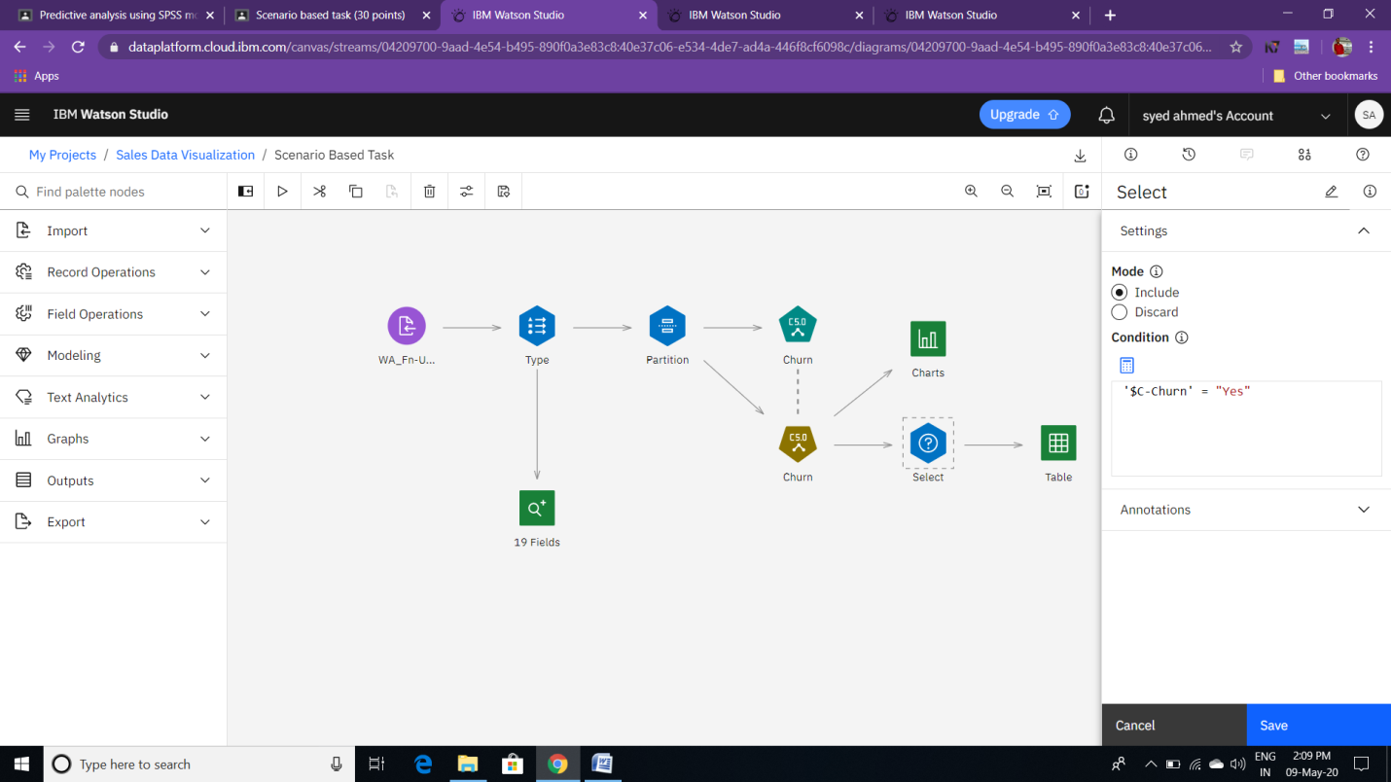

**Task 8**: Customers of the Criteria who are going to Churn.

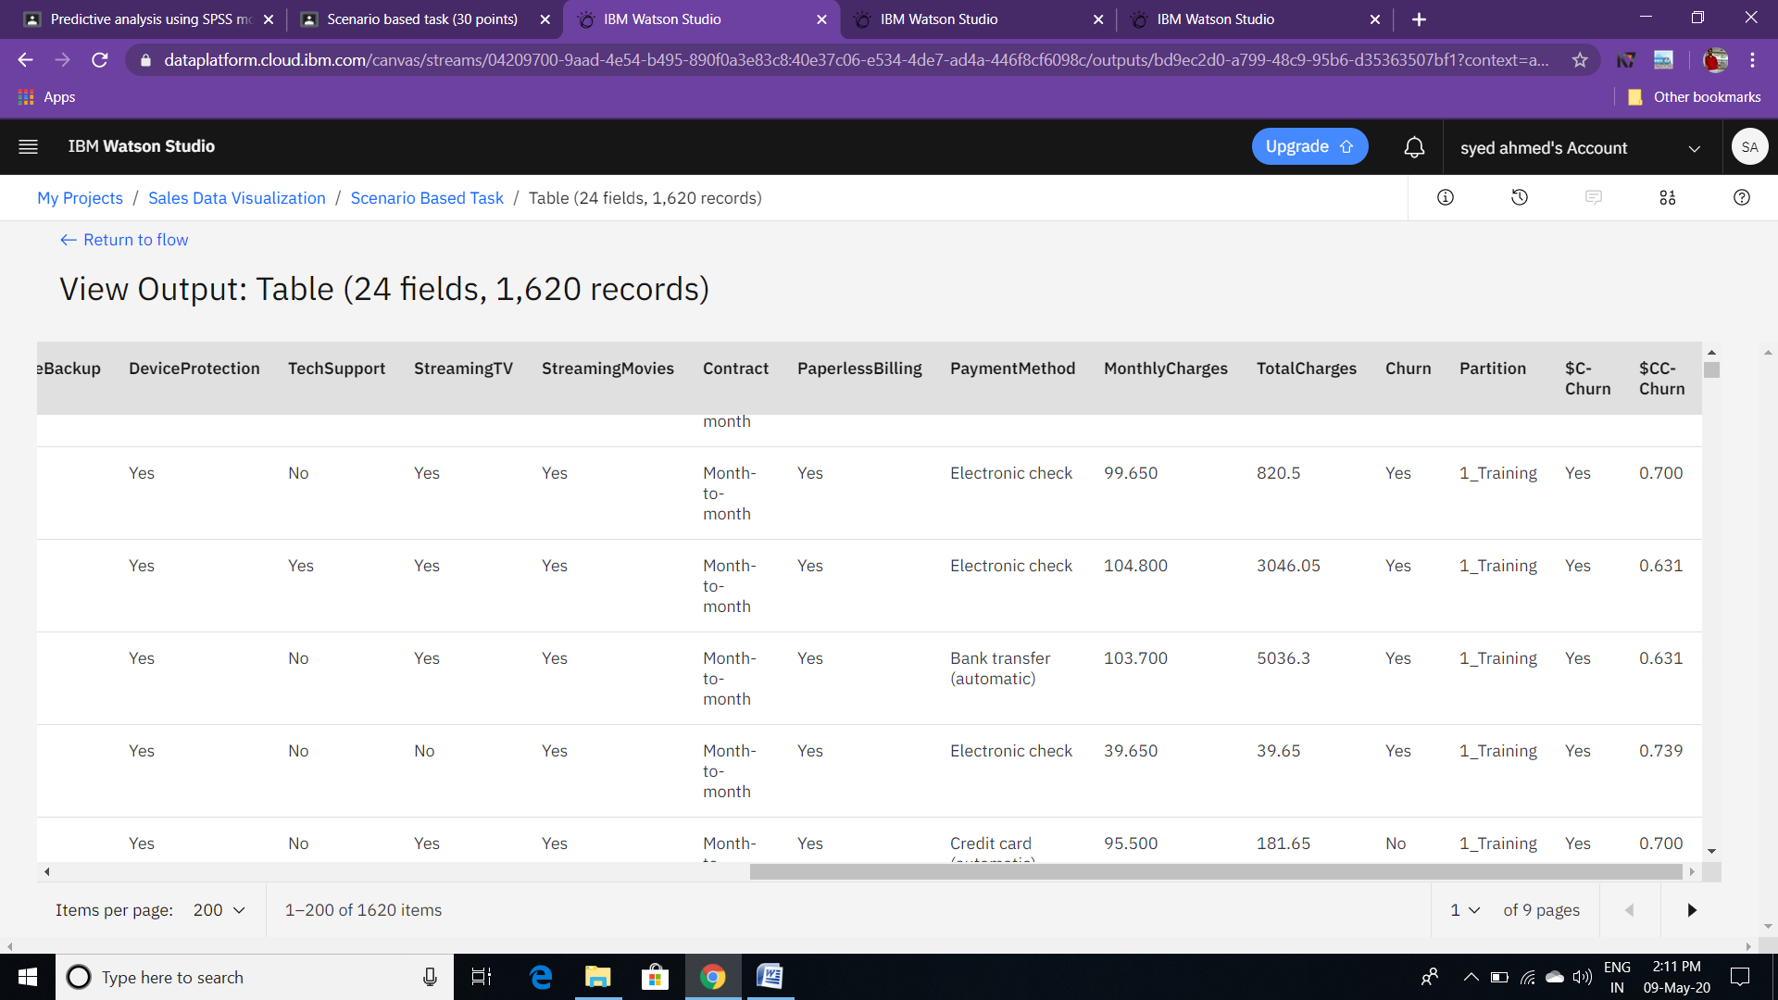

**Task 9:** Scatter plot is been used to forecast the values Gender v/s Predicted Churn Value.

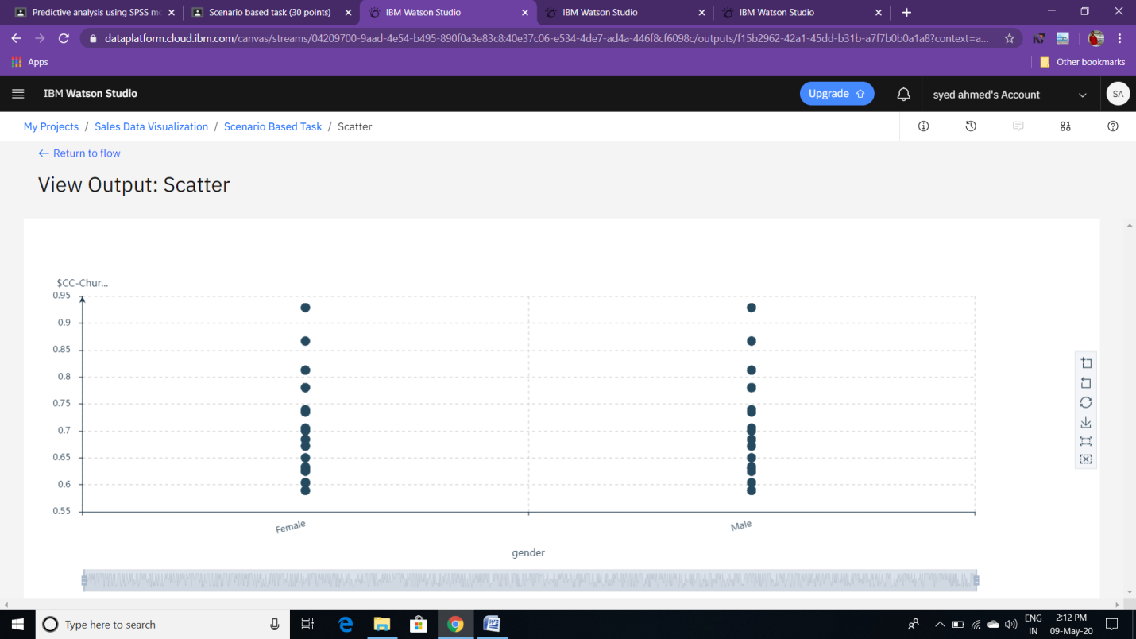

* Before performing the task , I have attached Auto-classifier Model to type-Node to check which one of the tree Model shows me the higher Accuracy.

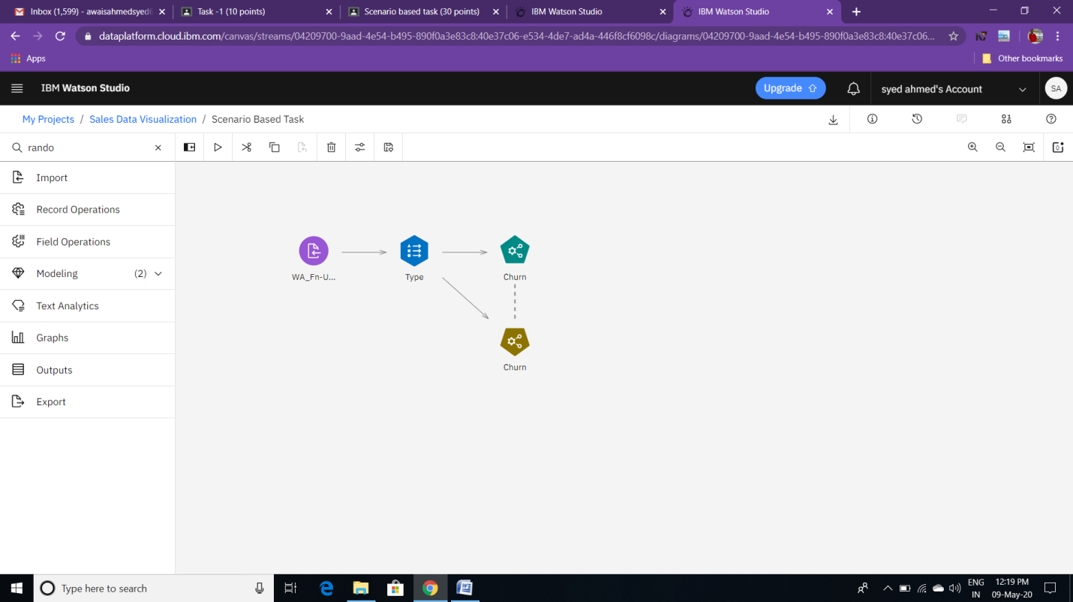

* Here it shows me the result as ,C5.0 Model has the higher accuracy as compared to the other Models.

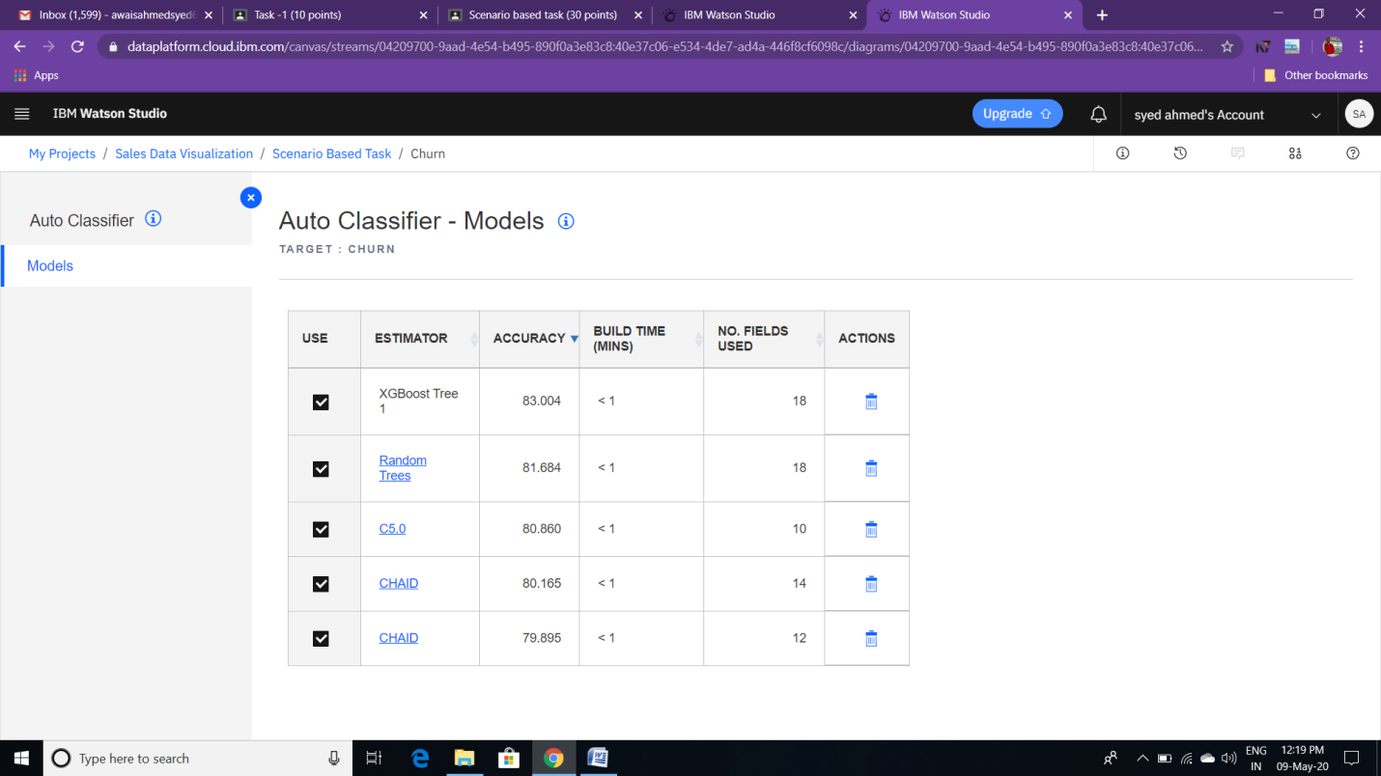

--------------*******Thank You******---------------